Biographical Notes and Lineage for
GENERAL JOHN BELL HOOD and His Family

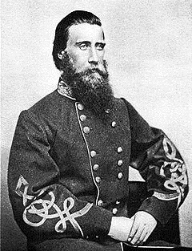General John Bell Hood's fate had gone from worse to worst after his fall at the Battle of Franklin, TN. The story of Hood trying to overcome the tradgedy of continuous loss was perpetuated by those friends and foe alike who carried on after his death to help the Hood orphans and to keep alive the General's memory.
The following is from an article by Kent Biffle in the Dallas News, 01-07-2001:
"The war behind him in 1866, General Hood married for the first time. He was 35. His wife, Anna Marie Hennen, was the daughter of a prominent Creole family. While he dabbled in business, the Hoods lived with her parents. A yellow fever outbreak in 1868 spared merchant Hood but the resulting quarantine cut his trade.
The much mutilated general remained much a man. In his first decade as a husband, he sired 11 children - among them three sets of twins. Old foe General Sherman helped him sell his military papers. But in 1879, yellow fever again stalked the canals and back alleys of New Orleans. The virus killed the general, his wife, and their oldest daughter. Historian T. Lindsey Baker, director of the Texas Heritage Museum at Hill College, has assembled a touching exhibit recalling a time when the orphan children of General Hood were a favorite charity. As a philanthropic venture, Hood's Orphans became a favorite, a sort of old-timey March of Dimes.
Throughout the U.S., generous friends and former battlefield enemies, as well as veterans of the Hood's Texas Brigade Association, contributed to the support of the orphans. Donors bought mass-produced pictures of the youngsters,'; said Dr. Baker. Former CSA General Pierre T. Beauregard organized a campaign that at last led to the adoption of all the children.”
The New Orleans home of Genl. and Mrs. John Bell Hood
General Hood, his wife, Anna Marie Hennen, and their eldest daughter, Lydia, succumbed to yellow fever in this house.
Anna Marie Hood's elderly mother survived them, but poor health caused her death one year after her daughter and son-in-law. With no means of support, the ten surviving orphans were adopted by the following families The sadness of the story goes further down as the orphans are kept apart in great distance, except for the twins. A charity fund was established and raised over $30,000 for the support and education of the Hood orphans. Anna would die in infancy and so the surviving nine children received their shares of the fund each at the age of 21. Eventually, the families came back together.
Below is the famous 1879 picture of the 10 surviving Hood orphans, signed by members of the Hood family on Aug. 30, 2003.
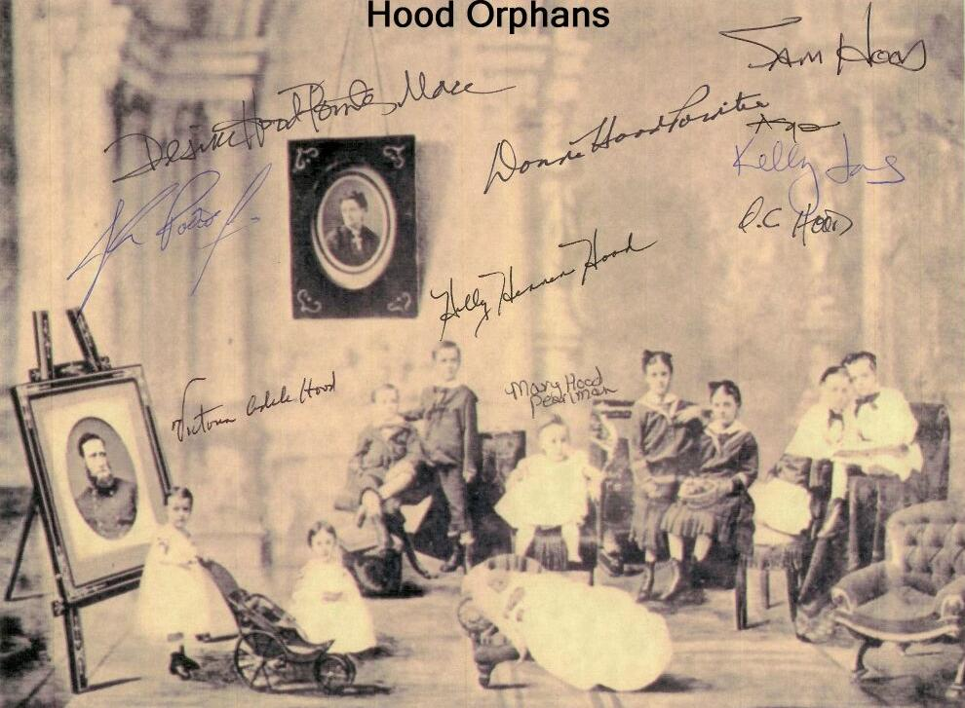

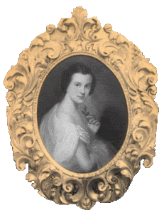
The Children of General and Anna Marie Hennen Hood (with their adoptive parents) were:
Annabel and Ethel Hood (twins) - Mr. and Mrs. John Morris, New Orleans
John Bell, Jr. - Mr. and Mrs. James Russell, Jonestown, Mississippi
Duncan Hood - Miss Clementina Furness, New York City
Marion and Lillian Hood (twins) - Mr. and Mrs. Thatcher Adams, New York City
Odile and Ida Hood (twins) - Mr. and Mrs. George T. McGehee, Woodville, Mississippi
Oswald Hood - Mr. and Mrs. Charles H. Harney, Lexington, Kentucky
Anna Hood - Mr. and Mrs. Moses E. Joseph, Columbus, Georgia

Hood Descendants
Thank You! Sam Hood gave his kind permission as the President of the Museum of the Confederacy in New Orleans, for use of the information and photos herein. Sam strives to perpetuate the memory of Gen. Hood. The Kin of Rock and Roll wishes to thank Sam and his organization for the beautiful tribute to this gallant leader and family member.
Below, the great-great grandchildren of General John Bell Hood and his wife, Anna Marie Hennen.
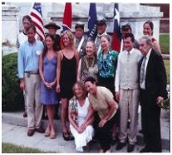
Sam Hood at General Hood's tomb

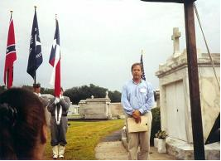

The Ghost of Anne Mitchell Haunts the Hood Home in Kentucky
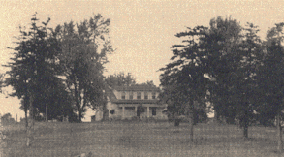
The Hood Family Home

THE CURSE OF ANNE MITCHELL
“The state of Kentucky was a place of great tragedy during the Civil War but not all of the ironic, mysterious or heart-breaking tales were the result of battle, imprisonment or disaster. One of the most forgotten tales of the war speaks of lost love, a dying woman’s final curse and one of the famed generals of the Confederacy.
Near Mount Sterling, Kentucky, there once lived a young woman named Anne Mitchell. She was a dark-haired girl of great beauty who many people called "the belle of Central Kentucky". Anne was known throughout the region as a gentle and sweet girl and as she grew older, she had her choice of suitors from around the area. However, in her late teens, she fell in love with just one of her gentleman callers, a tall, blond youth named John Bell Hood.
Hood was the son of Dr. John W. Hood, who lived near the Mitchell home and who operated a small farm and a medical school for aspiring doctors. The younger Hood went to West Point in 1849 and when he returned home on furlough, he began courting Anne Mitchell. The two of them fell passionately in love. They often met for walks in the evening and their favorite trysting place was in the garden of the Hood home --- a place where Anne’s ghost is still said to walk today.
The ghost of Anne Mitchell is still said to appear around the old Hood homestead in Kentucky. She and her lover once walked in the garden here -- and her ghost still does.
According to the legends, another young man came on the scene as a rival for Anne’s affections. He is remembered today as only "Mr. Anderson", and although Anne did not care for him, her family took to him immediately. Unlike Hood, Anderson was very wealthy and promised Anne’s parents that he would build her a home on property which adjoined their own.
Anne’s family began to pressure her incessantly and finally, she agreed to marry Anderson on the condition that she be able to write a letter to John Hood at West Point -- a letter that would be read only by him. In her letter, Anne poured out her heart to the young cadet and promised him that she "would love him forever" and "whether in this world or the next, she would only walk the garden path with him".
Not surprisingly, when Hood received the letter, he immediately left school and rode for Kentucky. He managed to get Anne a message and promised to meet her a few nights later near her home. He promised to have an extra horse saddled for her and together, they would ride off and be married. As it happened though, one of the Mitchell slaves discovered Anne’s absence only minutes after she left for her rendezvous with Hood and raised the alarm. Anne’s father and brothers went in pursuit of her and discovered the young lovers just as Hood was putting Anne on her horse. She was quickly returned home and was locked in her room and not allowed to leave until the day that she married Anderson. Confined to her room, Anne could only peer out the window of the house at the Hood homestead and at the garden where she and Hood had once walked. She never stopped loving him -- and she never forgot the lifelong punishment that she felt her family had inflicted upon her.
A few months passed and Anne’s family, as well as her new husband, breathed a sigh of relief when Anne and Anderson finally exchanged their wedding vows. Little did they know however , their troubles were just beginning. Despite the affection and wealth that was heaped upon her, Anne refused to forgive the fact that she had been forced to marry a man she did not love. She refused to leave her room in the old Mitchell house and remained moody and depressed. When she learned that she was pregnant, she stopped speaking altogether and even Anderson himself was banned from entering her rooms.
When she finally spoke again, it was after the birth of her son, Corwin, and what she uttered made everyone’s heart stand still. Her words were a curse.... "upon all who had any part in making me marry Anderson when my heart will always belong to John Bell Hood." As the legend goes, the curse began to have a dire effect on the family just a few hours after Corwin was born.
Late that afternoon, the sky overhead began to darken and a strangely localized thunderstorm swept through the area. A lightning bolt struck the corner of the Mitchell house and a portion of the brick home collapsed. Although nothing else in the area was damaged, three people at the Mitchell house were killed -- including Anne herself. Also dead were one of Anne’s brothers, who had been involved in stopping Anne and Hood from eloping, and the slave girl whose warning had sent the Mitchell men in pursuit of Anne when she ran away.
After three persons died within hours of Anne uttering a curse on the family, the story of the curse soon began to spread. In the years that followed, it began to be taken quite seriously. People from all over the region told and re-told the story of Anne’s last moments on earth and the malediction that she uttered just hours before her death. And they watched in fear as the warning in the curse began to come to pass.
Anne’s son, Corwin Anderson, died from the shock of witnessing a fatal assault on his youngest son by his oldest. The elder son, named English Anderson, was a brutal man and had narrowly escaped conviction after murdering a cook who worked for his family. In this instance, he knocked his brother from a horse with a brick. Corwin staggered to his bedroom and died of a heart attack and the youngest son perished from his injuries a short time later.
English Anderson did not fare well either. Soon after the deaths of his father and brother, he killed a man in a knife fight, then beat to death a young boy who was working on his farm. In revenge, a group of other farm workers actually stoned him to death.
The family continued to be plagued with strange and violent deaths as the years passed and descendants believed them to be the results of the curse. As recently as the 1940’s, Anne’s great-grandson, Judson Anderson, inexplicably walked into a pond on his farm, drew a gun and shot himself in the head.
The various residents of the Hood homestead, who moved in after the Hood family left, had little luck either. One owner committed suicide and another attempted to take his own life after an unhappy love affair. In the local area, both events were attributed to Anne’s influence.
Although her curse was certainly a malevolent one --- her lingering ghost is considered to be a better reflection of her truly gentle soul. Many locals spoke of seeing her wandering the gardens of the old Hood home and she was never believed to have frightened anyone, despite some reported encounters with shaken residents of the property. Her haunting has always been a quiet one and if the stories are to be believed, it remains so today. With all of the victims of Anne’s fatal curse, one has to wonder what became of John Bell Hood after their separation. Some believe that her restless spirit may have inadvertently passed the effects of the curse on to him, despite how much she loved him, because Hood’s career was forever shadowed by failure and tragedy.”

© Copyright 2003 by Troy Taylor. All Rights Reserved.
BOOK EXCERPT FROM SPIRITS OF THE CIVIL WAR

