ROSELLA’S TRUE STORY
as told by Mackey Hargett

Biographical Notes and Lineage for
ROSELLA ELIZABETH PRESSLEY
The story of Rosella Elizabeth Pressley was a sad one, but a story no different than a young woman living through the reconstruction period of a war between states, a young woman whose daddy left her, her mother and her sister when she was just a child. A young woman whose mama, Martha Jane Wesson Pressley, had died in childbirth in 1868 after remarrying a man named William Steele. Afterward, the girls went to live for a time with their grandmother, Millie Brown Wesson. William Steele, a Civil War veteran had abused his step-daughters and fathered the first born of each, including Rosella's first born, Walter G. Pressley who was born December 19, 1880. Rosella's children would all retain the surname of “Pressley/Presley,” Rosella’s maiden name. Someone going by the name of Valley J. Presley of Texas believed that his father, William Steele, was Rosella's stepfather. This has yet to be confirmed.
Young “Rosie” grew up penniless on White Springs Road in the small farming community of Tilden, Itawamba County, Mississippi, where the men were scarce having been off to war, and the means of support were minimal at most. The Union army had stormed through Itawamba County and destroyed many of the farm buildings and homes and absconded with livestock, leaving many families destitute.
Rosella, together with her sister, Rosalinda, made their home on White Springs Road. The two young women needed the means to support themselves and their firstborn children, and with no family but for the neighbors who had become family to them, Rosella became independent of her own means and started in to sharecropping her land.
John Wallace and his wife, Elmira McFadden Wallace, lived nearby and it was not long before Wallace fell for the young, attractive woman who had developed an independent air, meanwhile, longing for the happiness and security of a solid and loving relationship. What was difficult most was that the men who weren't lost to the war or damaged from it were all married.
A strong woman and yet a woman who was a victim of both the times and of her environment, Rosella managed to raise 10 children on her own, all of whom respected her as their mother and accepted her position, though most would be embarrassed by the truth of their illigitimacy and try to cover for the situation out of respect for their beloved mother.
Rosella Pressley and John Wallace shared some trials in their lives, however, fate surely brought them together because out of their love for one another came the greatest entertainer in the world and of generations to come, Elvis Presley. Though neither would live to see this success, the long-kept mystery is now revealed: that John Wallace is the true great-grandfather of Elvis Presley.
It was easy to see that John Wallace had developed a deep love for Rosie Pressley and cared for her enough to support both her and their children. Before he had met Rosie, however, John had married Elmira McFadden on December 20th of 1880 and sired nine children with her, to wit:
- Elnora Wallace* b. Sept. 1, 1882 in Itawamba County, MS. She married Joe Yarber. They had a child Lillian Yarber born October 24, 1905. Lillian married Tearsie Edward Hargett born August 12, 1910 of Marion Co.., Alabama and they were the parents of Mackey Edward Hargett born August 24, 1943 in Tupelo, MS. Elnora died on Dec. 14, 1971 in Tishimingo Co., MS and Lillian Yarber Hargett died January 23, 1989 in Tishimingo Co.
- Bettie Lou Wallace b. March 1885. She married Jesse Martin. She died in Red Bay, AL in 1980.
(3) Robbie C. Wallace b. August, 1886 in Itawamba Co. She married George Huff. Robbie died in 1929 in White Co., AR
(4) Ossie Howard Wallace b. June 18th 1888 in Itawamba Co. He married Mary Barkley. Ossie died January, 1970.
(5) John Kirby (Curb) Wallace b. Oct. 24, 1889 in Hawthorn Co., MS. He married Rosa Cox. John died 1957 in Tupelo, OK.
(6) Selma Ann Wallace b. November, 1891 in Itawamba Co., MS. She married Hollis Huff. Selma died in 1985 in Enciniatas, CA.
(7.) Jessie Pearl Wallace b. April 21, 1895 in Itawamba Co., MS. She married John Graham. Jessie died November 11, 1980 in Tremont, Itawamba Co.
(8.) Willie Mae Wallace b. February 1898 in Itawamba Co., MS. She married Sid Smedley. Willie Mae died January 19, 1995 in Itawamba Co.
(9.) Archie Homer Wallace b. February 12, 1903 in Itawamba Co., MS. He married Alvilee Swindle. Archie died July 17, 1994 in Columbus, MS.

The Children of Rosella Presley and John Wallace are:
(1.) Jesse D. McDowell Pressley/Presley, the grandfather of Elvis Presley, b. April 9, 1896 in Itawamba Co. Jessie married Minnie Mae Hood and then Vera Leftwich. Jessie died 19 March 1973 in Louisville, KY.
(2.) Calhous “Cal” Pressley/Presley b. 9 May 1899 in Itawamba Co. He died in East Prairie, MO.
(3.) Mack Pressley/Presley b. Oct. 2, 1901 in Itawamba Co. and died 1917 in Tremont, MS. He is buried in Priceville Cemetery in Tupelo, MS.
(4.) Robbie Pressley/Presley b. March 1, 1903 in Itawamba Co. She married Otis Stacey. Robbie died Sept. 9, 2001 in Tupelo, MS.
(5.) Joseph Warren Pressley/Presley b. January 6, 1907 in Itawamba Co. He married Delma Jackson. Joe died July 16, 1979 in Red Bay, AL.

John and Rosella stayed together also as a couple throughout the years of 1880 to 1935 when John had passed away. He is buried in Salem Cemetery with his wife, Elmira who died in 1934.
No one will ever know or understand Rosella's reasons for staying with John Wallace other than she loved him deeply and he took care of her and their children. For many years Rosie never told her children who their natural father was, nor was it known in the town where John Wallace was a prominent member of society.
Thanks to cousin Mackey Hargett, the truest factual account of Rosella Presley's life is now consecrated in book form. Mackey originally told Rosella and John's story to Mississippi historian , Julian C. Riley, who began further research into the story and made it his own project called “The Roots of Elvis Presley.” Mackey had waited many years to acknowledge the truth of this portion of the Presley family history, mainly because he was keeping a promise to someone who's wishes meant most to Mackey. Having fulfilled his word, Mackey now feels that it is time for John Wallace to be presented in the same light enjoyed by other family members. John, after all, helped to create the legend, Elvis Presley, and is Elvis' natural great grandfather as he is Mackeys.

NOTE: Jerry Presley, although a distant cousin of Elvis Presley, has falsely claimed that Rosella had married his grandfather, John, thus making Jerry and Elvis second cousins. This is absolutely untrue despite that Jerry Presley had himself placed in the original book telling Mackey’s story by then author, Jim Browder. Presley and Browder worked together to insure that Jerry had a place in that printed story. However, that book has been recalled and a second one printed, “The Roots of Elvis Presley” which is still selling on Amazon. Again, the truth is that Rosella Presley never married and none of her grandchildren knew of Jerry Presley.

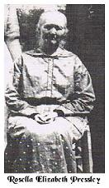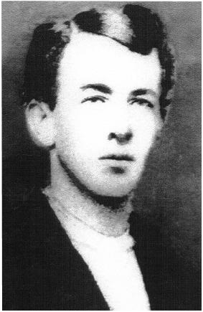John Wallace

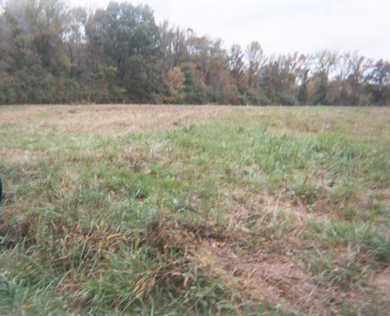Land once owned by John Wallce in MS.
(photo by Barbara Lee Rowe)

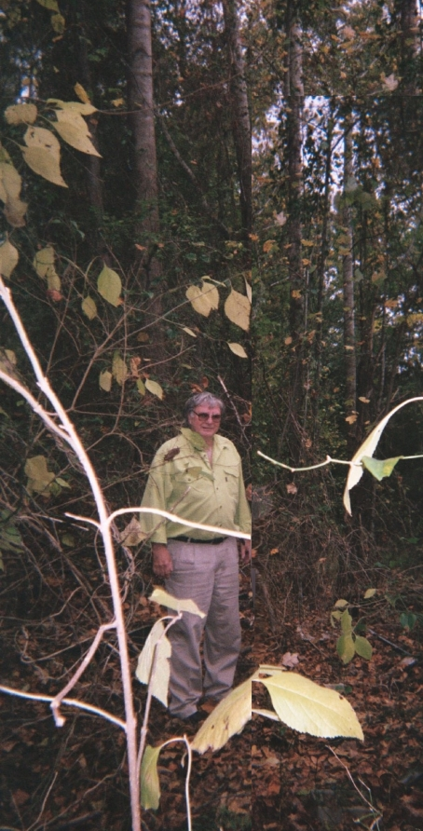Mackey Hargett standing on land where Rosella Presley’s home once stood.
(photo by Barbara Lee Rowe)

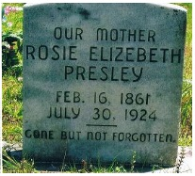

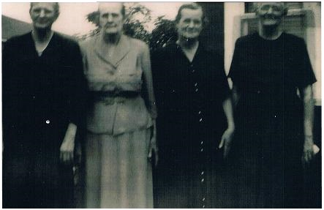The daughters of John Wallace and Elmira McFadden. Mackey’s grandmother, Elnora, is at left. Photo ctsy. of Mackey Hargett.

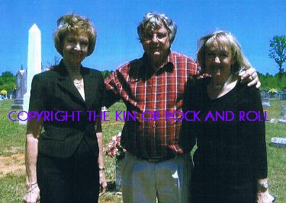Mackey Hargett with Patsy and Jeddie, daughters of Joe Pressley, son of Rosella Pressley and John Wallace. Patsy and Jeddie are 1st cousins to Vernon Presley and 1st 1x removed to both Elvis and Mackey.

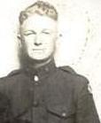Jesse D. Presley
in WWI stateside service.

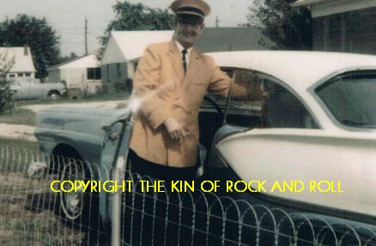Jesse D. Presley, Elvis’ granddaddy, with the care Elvis bought for him.

