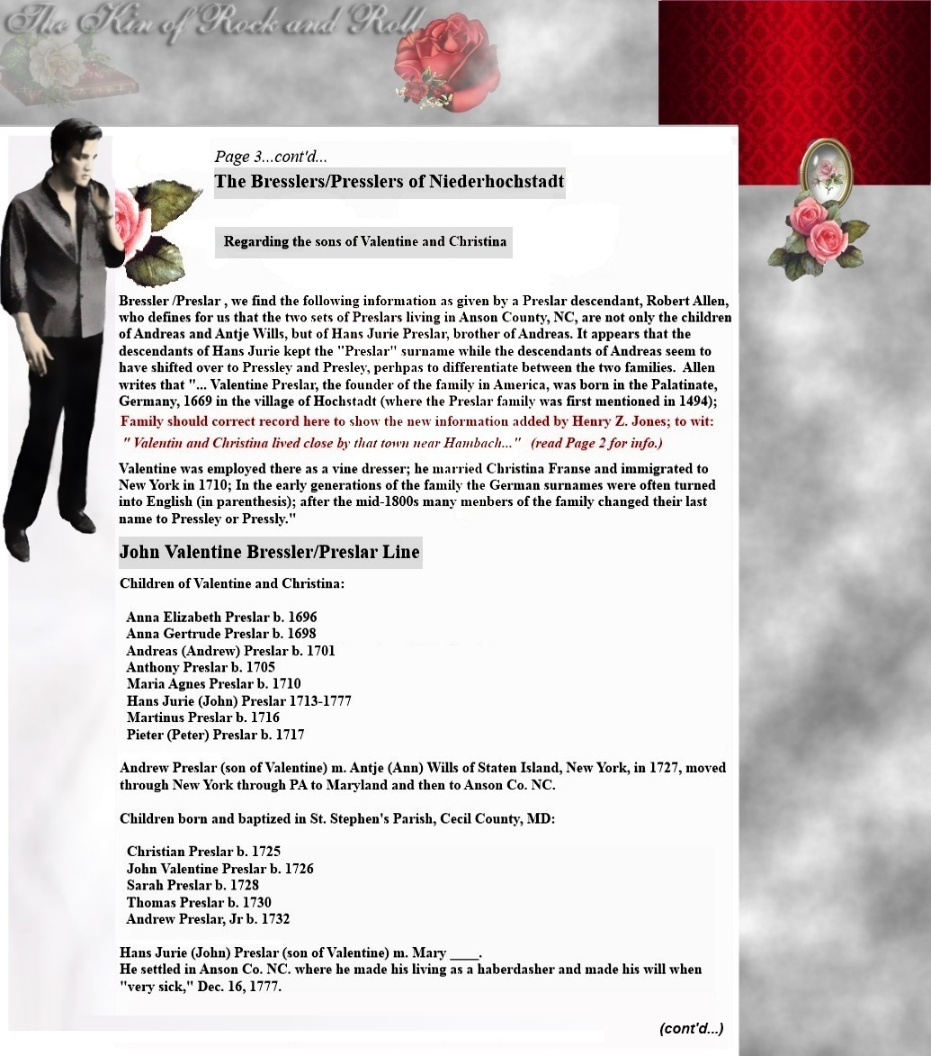

Biographical Notes and Lineage for
John Valentine Bressler/Preslar

