Susannah Presley, eldest daughter of Thomas Presley and Sarah or Elizabeth Culpepper
submitted by Barbara Lee Rowe

Biographical Notes and Lineage for
SUSANNAH PRESLEY
Susannah Presley was born ca. 1754. She married John “Blackhead” Helms b. 1756 in 1785 in Anson County, NC. (source: Anson County, NC - County Index to NC Marriages Database - Part 1 Anson County, NC,County Index to the North Carolina Marriages Database) John was the eldest son of George Helms, Sr. and Mary Margaret Faulkenburg (i.e. Falconbury, Fortenberry)
The children of Susannah Presley and John “Blackhead” Helms are:
1. Anna HELMS b: 1774 in Anson County, North Carolina
2. John HELMS** b: 1781 in Anson County, North Carolina
3. Joel HELMS* b: 1783 in Anson County, North Carolina
4. Susannah HELMS b: 1787 in Anson County, North Carolina
* Joel Helms was born in Anson County, North Carolina ca. 1783. He married Sarah (Sary) Hargett b. 1785 in Anson County, NC, daughter of Henry Hargett, Jr. and Anna Charity Broom before 1808 in NC. We have documents to state the Sarah was the daughter of Henry, but we do not have a marriage bond or note for Joel Helms and Sarah Hargett. Sarah would have either divorced or died before 1833. It may be that she died in childbirth as her last child is born in 1829.
The mystery of which Henderson Helms is which son of which Joel is clearly validated with the birth of Henderson Helms born in 1810, according to the 1850 census where he is listed as 40 years old. This Henderson Helms is the oldest of three cousins named Henderson Helms. According to the 1820 census for Anson County, NC, Joel Helms is listed with two sons 10 years and under. That would be Henderson Helms, born in 1810, and John Helms, born in 1811. Joel and sons are found to be in Barbour County, AL, by 1833, Joel in several instances before he relocates to GA is particularly referenced as a “bondsman” here. Before going to AL, on 13 October 1833, Joel Helms married Mary McGuirt in NC. The bondsman was David McGuirt. The witness listed as Henderson Helms. On 12 Nov. 1833, in Barbour County, AL, Joel is bondsman for David McGuirt who married Rebecca Winchester. On 7 Jan. 1834, Joel witnesses the wedding of his son, John Helms, in his marriage to Holly Chaney. Bondsman is Jackson Chaney. Joel and Mary relocate to Pike County, GA, where they reside until Joel's death in Spalding County sometime between 1847 and 1849. Joel's youngest children, Maranda and Mirinda Helms, were twins born in 1847. According to the 1860 census in Spalding County, GA, Mary Helms is 43 years old living in the Line Creek district, Erin, with her children: Lucena, 18; Isaac J., 17, and Marinda and Maranda, 13. (source: Mecklenburg County, NC Marriage Bonds before 1900-transcript, US and International Marriage Records 1741-1868, 1820, 1850, and 1860 census records)
Isaac James Helms went on to marry Adeline Dingler. He served in the CSA in a Georgia infantry unit. Afterward, he became relocated with his family to Cullman County, Alabama, and became a Baptist preacher. He died 25 May 1920 and is buried in AL. His sister, Maranda Helms, had also married a Dingler. She passed away at 34 years of age from flux and is buried in GA. Both Joel (J.J.) Helms, age 65, and wife, Mary, age 61, are buried in Riverdale Cemetery in Columbus, GA, not far from the AL border. They are buried amid members of the McGuirt family.
The children of Joel Helms and Sarah Hargett are:
1. Lucinda HELMS b. ca. 1809 in Anson County, NC
2. Henderson HELMS b. 1810 in Mecklenburg County, NC. (chart submitted by Barbara Lee Rowe)
3. John HELMS b. 22 FEB 1811 in Mecklenburg County, NC **(chart submitted by Beverly Brown.)
Rev. John Helms was married to Hollie Chaney. Their children are as follows:
a. Zilpha Luiza Helms b: 30 Oct 1834
b. W. M. Madison Helms b: 29 Dec 1835
c. Martha Jane Helms b: 22 Apr 1837 d: 10 May 1915
d. John Jackson Helms b: 21 Sep 1838 d: 1922
e. George Washington Helms b: 12 Jan 1840
f. Sarah Ann Helms b: 24 Feb 1841
g. Joel Sim Helms b: 30 Oct 1842
h. Milbra Sophina Helms b: 17 Aug 1846 d: 30 Mar 1923
i. Aaron Nelson Helms b: 12 Nov 1847 d: 22 Apr 1929
j. Hollie Emaline Helms b: 16 Nov 1849
k. Jacob Samuel Helms b: 5 May 1851 d: 4 Feb 1925
l. Lee Andrew Helms b: 13 Nov 1852
m.Joseph Henry Helms b: 13 Nov 1854
n. Mary Unicy Helms b: 16 Mar 1856
o. Hilliard Helms b: 13 Nov 1857 d: 24 Aug 1922
p. Easter Helms b: 13 Jan 1861

4. Clarinda HELMS b. ca. 1812 in Anson County, NC. Clarinda married Strickland Hargett on 1 August 1833 in NC.
5. Eunice Amelia HELMS b. MAR 1813 in Mecklenburg County, North Carolina.
6. Anne HELMS b. ca. 1815 in Mecklenburg County, North Carolina.
7. Henry Michael HELMS b. 23 FEB 1821 in Mecklenburg County, North Carolina. Henry Michael Helms n.c./ga married Mary Ann Akins. (Submitted by Thomas Howard .)
Child of Henry and Mary Ann Helms is:
Joel Thomas Helms who married Martha Elizabeth Ison
Their child was:
Addie Mae Helms who married Curren P. Howard
Their child was:
Thomas Jefferson Howard who married Lila Grubbs
Their child (plus others living not published here) is:
Thomas Howard, living
8. Rachel HELMS b. 1823 in Mecklenburg County, North Carolina ***
9. Michael HELMS b. 1825 in North Carolina
10. Susan Huldah HELMS b. ca. 1827
11. William Levi Madison HELMS b. 4 AUG 1829 in Mecklenburg County, North Carolina. NOTE: There has been additional information on the William L. M. Helms line from Richard Helms who spoke to descendants of Helms. It appears that William L.M. Helms had a son who strayed from the family fold and was never heard from by the family again.
NOTES: **John Helms information taken from his family Bible and the following sources: record from Rev. John Helms Bible, Mrs. B. Helms, owner, Louisville, AL, obtained from John P. Johnson of Brundige, Ala. Names and dates verified by search of Barbour County, Ala. census: pg. 150, #622-1850, #373-1860, #381-1870, pg. #315-1880. Sara Myers and Jan Patterson.
“John Helms was born in 1811 and died in 1891. He was married to Holly Chaney in Mecklenburg County, NC on Jan 7, 1834. John's father was Joel Helms, a son of John “Blackhead” Helms, a son of old George Helms. John was often referred to as John “Chaney” Helms to distinguish him from the other Johns in the family. Holly Chaney, John's wife, was an only child of John and Milbra Chaney, who moved to Alabama with the Helms. Joel, John's father, started to Alabama with the others, along with his second wife and children. However, he (Joel) decided to settle in Pike County, Georgia. Holly died Nov. 19, 1883 and is buried in the Helms Family Cemetery in Blue Springs, Alabama. There are many graves in the cemetery, some not marked. After Holly's death, John Married Mary Jane Phillips, a sister of Dorcas Phillips, the wife of Jacob Samuel Helms, a son of John. No children were born to this union. 'THE HELMS FAMILY IN SOUTH ALABAMA, Lavinia Helms.” According to the 1870 census aforestated in source material, in Rev. John Helms household is living also his sister, Rachel.***

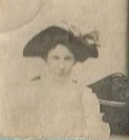Henderson Helms* b. 1810 in Mecklenburg County, NC, was a farmer by trade and lived in NC until 1831 when many of the Helms folks joined a wagon train and headed for Alabama, where they ended up in Barbour County: Blue Springs, Euphala, and Clayton. This was the same year that a large portion of the Hargett family also left NC for Alabama. The wagon train included many different families from NC.
When the War Between States broke out in 1861, Henderson Helms was 51 years old and had joined the Alabama State guards in what was known as the 4th Regiment Senior Reserves. Henderson remained in Barbour County, dying there in 1880. Henderson married Abigail Crowell, b. 19 January 1814 in Mecklenburg Co., NC, on 22 JAN 1834 in Mecklenburg County, North Carolina. She had been married before to Israel Helms, a cousin of Henderson who had passed away. Abigail had one child from that marriage, Alcy Elizabeth Helms. The photo above is said to be of Abigail Crowell Helms.
The children of Henderson Helms and Abigail Crowell are:
1. Emily J. HELMS b. 8 DEC 1835 in Union County, North Carolina
2. Josiah Franklin HELMS b: 21 SEP 1836 in Anson County, North Carolina
3. *Sarah Catherine HELMS b. 1840 in Mecklenburg County, North Carolina. Sarah married Josiah Wentz, son of John Wentz, Revolutionary War patriot.
4. Lafayette Israel “Drew” HELMS b: 26 DEC 1842 in Barbour County, Alabama - CSA m. *Julia Johnson, AL (*Hood family connection)
5. Cyrus Newton Secrest HELMS b: 27 DEC 1844 in Barbour County, Alabama
6. Elias John Wilson HELMS b: ca. 1847 in Barbour County, Alabama
7. Gilbert Washington HELMS b: 1849 in Barbour County, Alabama
8. Rebecca J. HELMS b: 1853 in Muscogee County, Georgia
9. George D. HELMS b: 1857 in Muscogee County, Georgia m. Julia, AL
10. John Wade HELMS b: 1860 in Barbour County, Alabama
11. Frances Harriett HELMS b: ABT. 1862 in Barbour County, Alabama. (sources confirming names taken from 1850, 1880 Goose Creek, Union County, NC, census and 1870 and 1880 Barbour County, AL, census. Sources also taken from Rowe/Winchester family Bible, death and marriage certificates, and scrapbook of Emily J. Helms Winchester in the possession of Barbara Lee Rowe.)
NOTES: Henderson Helms and wife, Abigail, had gone to Georgia for a period of about three years between 1853 and 1856. Two of his children were born there. Perhaps he had gone for obligatory matters brought on by the earlier death of his father, Joel (before 1850.) Henderson would have had younger brothers and sisters. Henderson and Abigail's eldest daughter, Emily, married in Dougherty County, GA in 1854, near where her family was at that time.

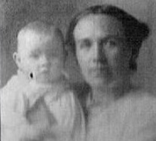Emily J. Helms married Samuel A. Winchester* 25 July 1854 in Dougherty County, GA. (source: Dougherty Co. GA, marriage bonds) Samuel was born in May, 1823, in Mecklenburg County, NC, the son of William D. Winchester and Mary “Polly” Wolfe. Samuel and Emily had moved back to Jackson, Union County, NC after 1881. Samuel died and was buried 23 June 1888 in Elmwood Cemetery in Charlotte, NC., his body having been listed as “unclaimed” which could mean the couple had separated or divorced. Emily went to live with her youngest son, John E. Winchester, in whose home she passed away on 17 August 1912 from “neuralgia of the heart.” (sources: 1870, 1880, NC,AL census, Emily Helms family book; family Bible. Photo of Emily Helms possibly with youngest son.)
The Children of Emily J. Helms and Samuel A. Winchester are:
1. William Ruffin Winchester b. 1856, Union County, NC and died 1881, Clayton, Barbour County, AL
2. Sarah D. Winchester, called “Josie” b.1859, Barbour County, AL. Sarah married ? Wolfe.
3. Georgia Anne Winchester, called “Ann” b 1861, in Barbour County, AL. Ann married ? Rogers and moved to SC.
4. Mary Josephine Winchester b. 1863 in Barbour County, AL. Died young.
5. John E. Winchester b. 1868, Barbour County, AL, and d. 13 March 1923. John E. Winchester married Laura E. Wentz in Union County, NC.
6. Thomas Winchester b.1872 in Barbour County, AL. Died young.
Children of John E. Winchester and Laura E. Wentz are:
a. Charlton Winchester m. Lizzie Gillis - descendants LIVING info. private
b. Jon EvaWinchester m. Clarence Myers - descendants LIVING info. private
c. Blanche Lorene Winchester b. 1901 in Charlotte, NC d. 1967 m. (1) Rev. Charles W. Rowe; m. (2) Oren Harvey - descendants LIVING info. Private.

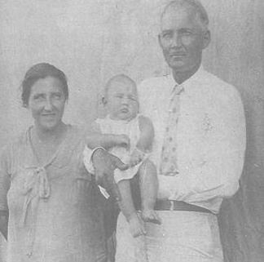The photo at left is of Blanche Lorene Winchester and Rev. Charles W. Rowe, a travelling minister. Blanche was Charles' second wife and twenty-five years his junior when they were married in 1929 in Webster Parish, LA. They are holding firstborn son, Charles Rowe, born in LA. Rev. Rev. Rowe died in 1937 and is buried in Texarkana, TX. The Winchesters are of Scotch-English and Tuscarora descent (Casiah/Keziah family), Blanche was born in 1901 in Charlotte, North Carolina, and Rev. Rowe in Walton County, Georgia. He moved to Texarkana, Texas where he died and is buried in Wooten Springs Churchyard.
The Children of Blanche Lorene Winchester and Rev. Charles W. Rowe* are:
- Charles E. Rowe -dec'd (info. private) descendant privacy
- William Rowe* - dec'd, m. Annette Cecelia B. 31 Oct. 1954. Dec'd
c. Anna Eleanor Rowe (married names unpublished) - dec'd. Descendant privacy
d. Franklin D. Rowe - dec'd at 13 years of age
The child of Blanche L. Winchester-Harvey and Oren Harvey is:
Frances Harvey (married name unpublished)- dec'd. Descendant privacy

The children of William Rowe* and Annette are:
a. Barbara L. Rowe LIVING (descendant information private)
b. G. Rowe LIVING (information private)

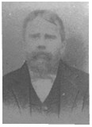Elias John Wilson Helms
son of Henderson and Abigail Helms, and his son,
Harvey Leroy Helms
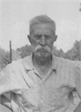

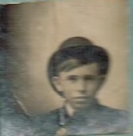William Ruffin Winchester
and John E. Winchester, below

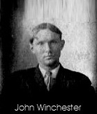
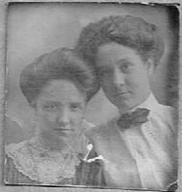
Georgia Anne (l) and Sarah D. Winchester

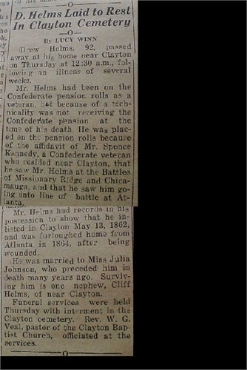Drew Helms, son of Henderson and Abigail Helms, CSA

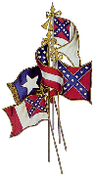

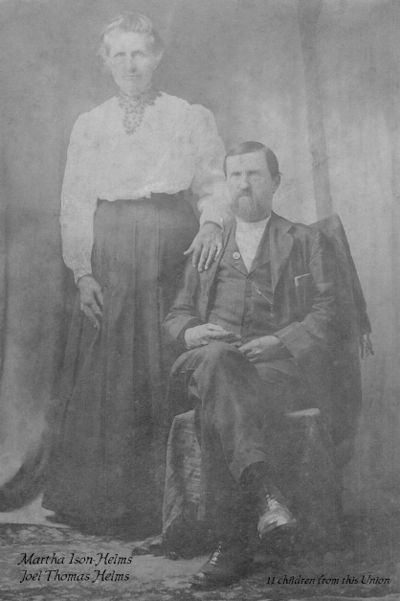Joel Thomas and Martha Helms, ctys. of
Thomas Howard

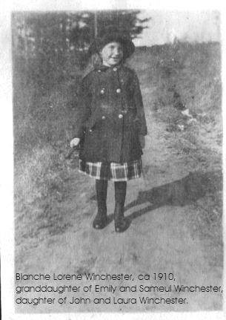
Blanche Lorene Winchester, aged 9, Charlotte, NC

